**Mathematics for Intelligent Systems**

Stock Market Prediction using Markov’s Model

T Uday krishna

AM.EN.U4AIE21064

amenu4aie21064@am.students.amrita.edu

J Viswaksena

AM.EN.U4AIE21035

amenu4aie21035@am.students.amrita.edu

# Introduction:

A Markov chain is a stochastic model that uses mathematics to predict the probability of a sequence of events occurring based on the most recent event. Markov-chains have many applications as statistical models of real-world processes, such as studying cruise control systems in motor vehicles, queues or lines of customers arriving at an airport, currency exchange rates and animal population dynamics.

Stock market is basically nonlinear in nature and the research on stock market is one of the most important issues in recent years. People invest in stock market based on some prediction. For predict, the stock market prices people search such methods and tools which will increase their profits, while minimize their risks.

In the project we are going to take stoke dataset from finance yahoo which is a real time data set. using the data set we are going to run some Stock Market predictions with Markov Chains

Markov Chains are a type of mathematical model that works on the principle of stochastic processes. A stochastic process is a mathematical object usually defined as a collection of random variables. In a Markov Chain, the probability of each event depends only on the state attained in the previous event. This property is known as the Markov Property.

In the context of stock market prediction, the states could be the rise or fall in the stock price. The Markov Chain model can be used to predict the likelihood of a rise or fall in the stock price based on the current state.

Depending on whether the data is instance or sequence, there two classes of learning algorithms. With sequence data, the order of the data points is considered an important aspect of the data and the learning algorithms will exploit the order in the data. Markov Chain Classification is a supervised learning algorithm for sequential data.

In our case, we will analyse each event pair in a sequence and catalogue the market behaviour. We then tally all the matching moves and create two data sets for volume action, one for up moves and another for down moves. New stock market events are then broken down into sequential pairs and tallied for both positive and negative outcomes

# Time Line:

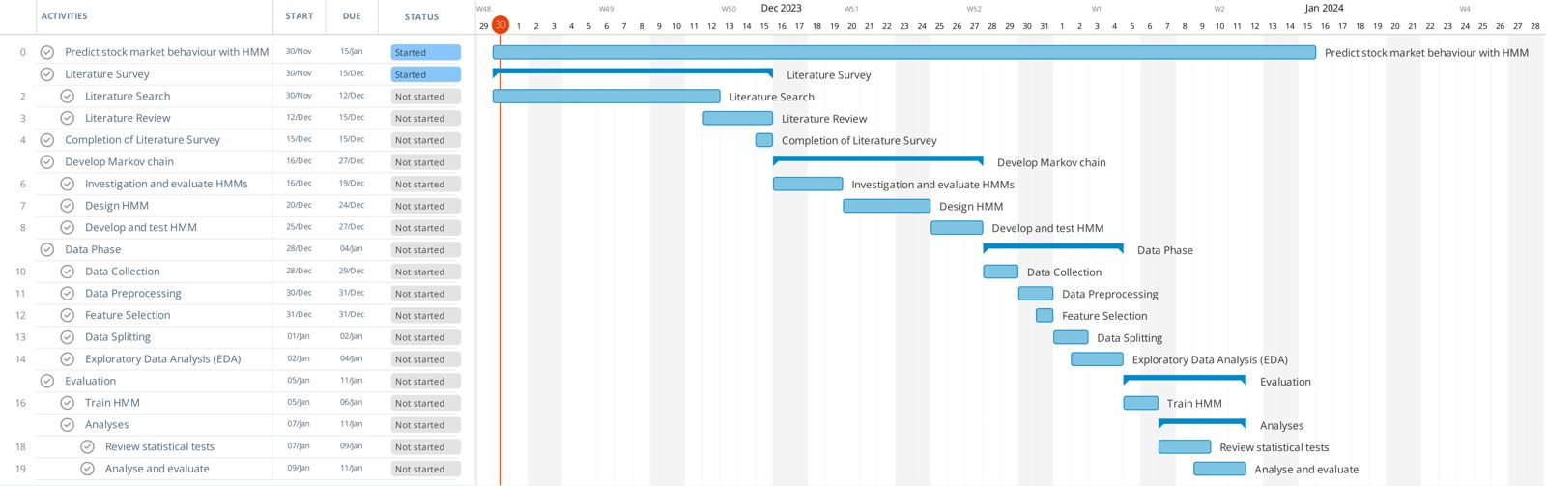

# References:

1. Padi, Tirupathi Rao & Dar, Gulbadin & Sarode, Rekha. (2023). Markov Modelling of Indian Stock Market Prices with Reference to State Bank of India. 9. 481-492.
2. Gulbadin Farooq Dar, Tirupathi Rao Padi and Sarode Rekha, Stock price prediction using a Markov chain model: a study for TCS share values, Advances and Applications in Statistics 80 (2022), 83-101. <http://dx.doi.org/10.17654/0972361722068>
3. Kavitha G, Udhayakumar A, Nagarajan D, Stock Market Trend Analysis Using Hidden Markov Models,
4. Prakash Kumar Sarangi, Birendra Kumar Nayak, Sachidananda Dehuri, Stock Market Price Behavior Prediction Using Markov Models: A Bioinformatics Approach, https://doi.org/10.1002/9781119785620.ch20